Course Title : Big Data Analytics
Course Code : Z1AMC 702
Name: Jayman Prajapati Registration No: 2511042210016

Experiment 7 : Sales Analysis - Top Products

Objective : Find the top 5 products by total sales.

Procedure:

Step 1: Prepare Mapper and Reducer

Create mapper and reducer Python scripts for processing city-wise sales data.

Step 2: Upload Dataset to HDFS

hdfs dfs -mkdir -p /user/$USER/sales_products/input
hdfs dfs -put sales_products_large.txt /user/$USER/sales_products/input/

Step 3: Run MapReduce Job

hdfs dfs -rm -r -skipTrash /user/$USER/sales_products/city_output

hadoop jar $HADOOP_HOME/share/hadoop/tools/lib/hadoop-streaming-*.jar \
-files mapper_city_products.py,reducer_city_products.py \
-input /user/$USER/sales_products/input/sales_products_large.txt \
-output /user/$USER/sales_products/city_output \
-mapper "python3 mapper_city_products.py" \
-reducer "python3 reducer_city_products.py"

Step 4: View Output
hdfs dfs -cat /user/$USER/sales_products/city_output/part-00000

Source Code
Mapper Code
#!/usr/bin/env python3
import sys

for line in sys.stdin:
line = line.strip()

if not line:
continue

parts = line.split(',')
if len(parts) != 4:
continue

try:
product = parts[1]
price = float(parts[2])
city = parts[3]

print(f"{city}_{product}\t{price}")

except ValueError:
continue

Reducer Code
#!/usr/bin/env python3
import sys

current_key = None
total_sales = 0.0
city_data = {}

for line in sys.stdin:
line = line.strip()

if not line:
continue

key, price = line.split('\t')
price = float(price)

if current_key is None:
current_key = key
total_sales = price

elif key == current_key:
total_sales += price

else:
city, product = current_key.split('_')

if city not in city_data:
city_data[city] = []

city_data[city].append((product, total_sales))

current_key = key
total_sales = price

# last key
if current_key is not None:
city, product = current_key.split('_')

if city not in city_data:
city_data[city] = []

city_data[city].append((product, total_sales))

# Print results
print("TOP PRODUCT PER CITY:")
print("=" * 40)

for city in city_data:
city_data[city].sort(key=lambda x: x[1], reverse=True)
top_product = city_data[city][0]

print(f"{city}: {top_product[0]} (₹{top_product[1]:,.2f})")

ScreenShot:
Part – A
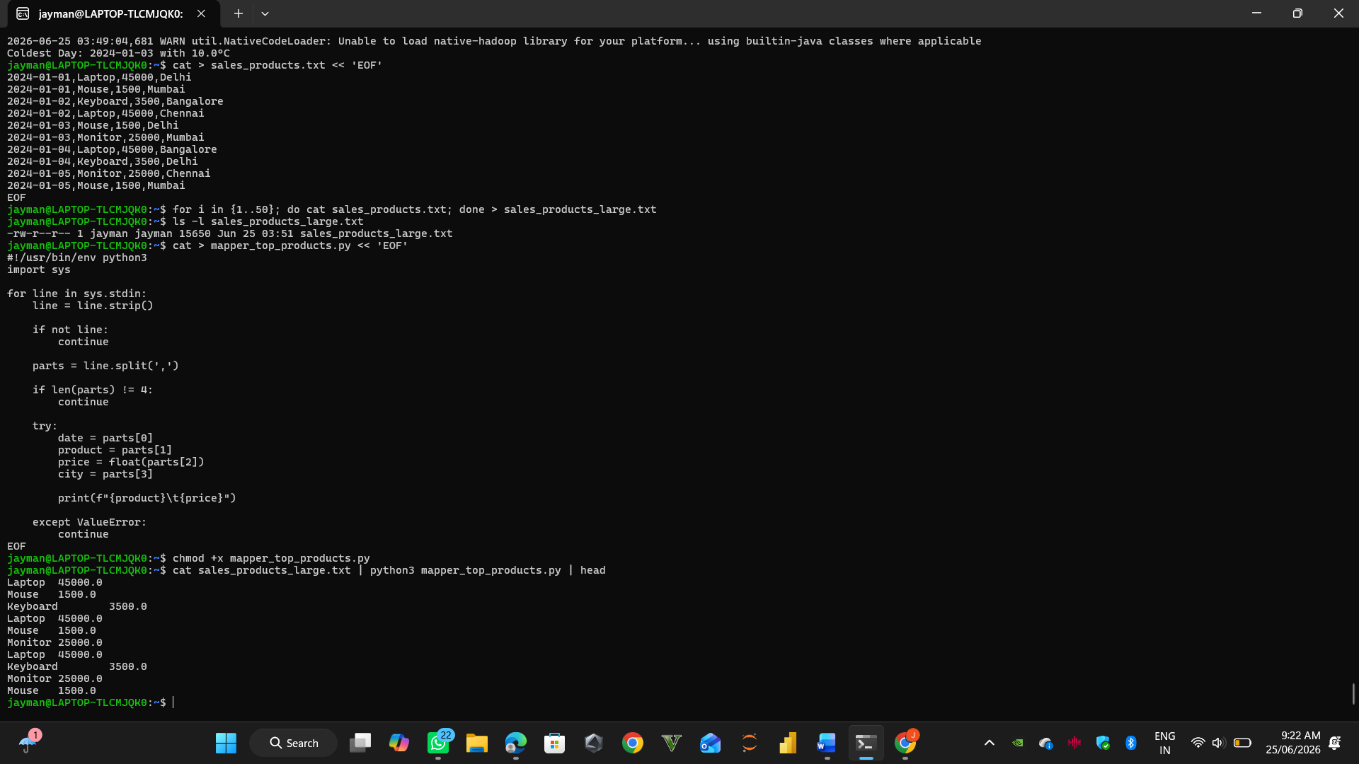
Part – B
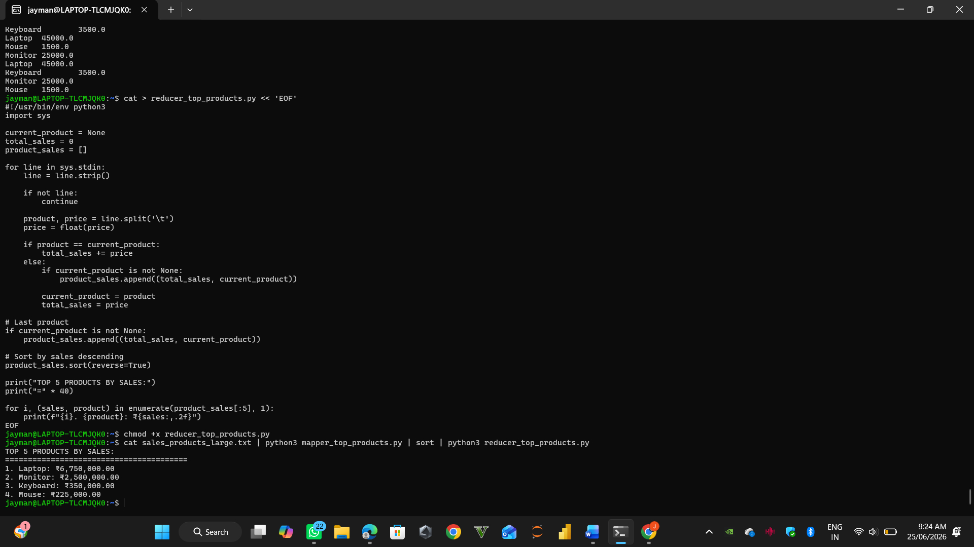

Part – C
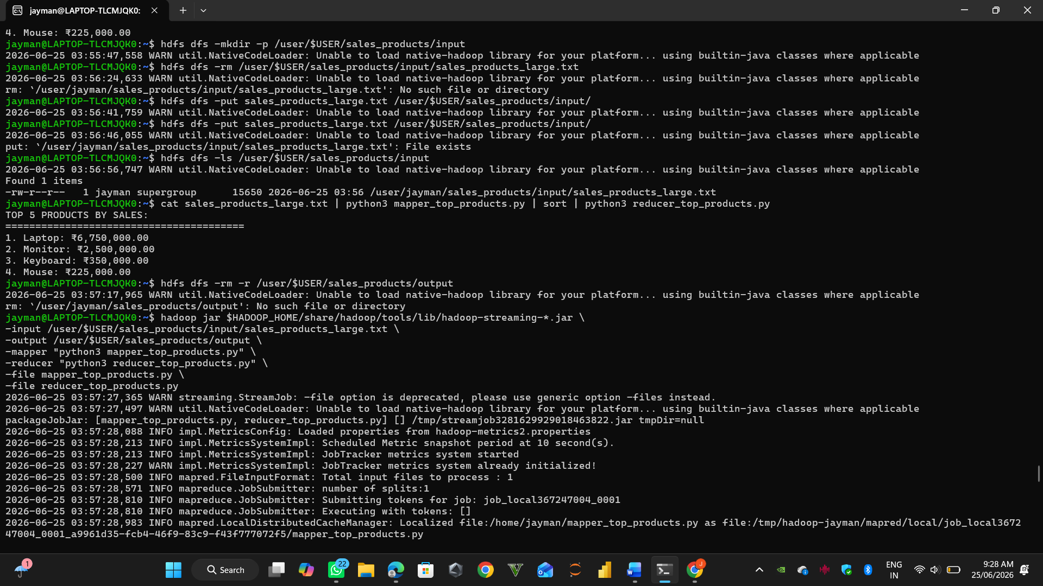
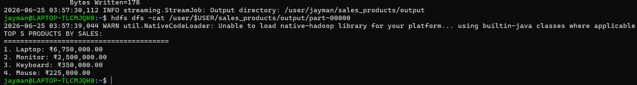

Part – D
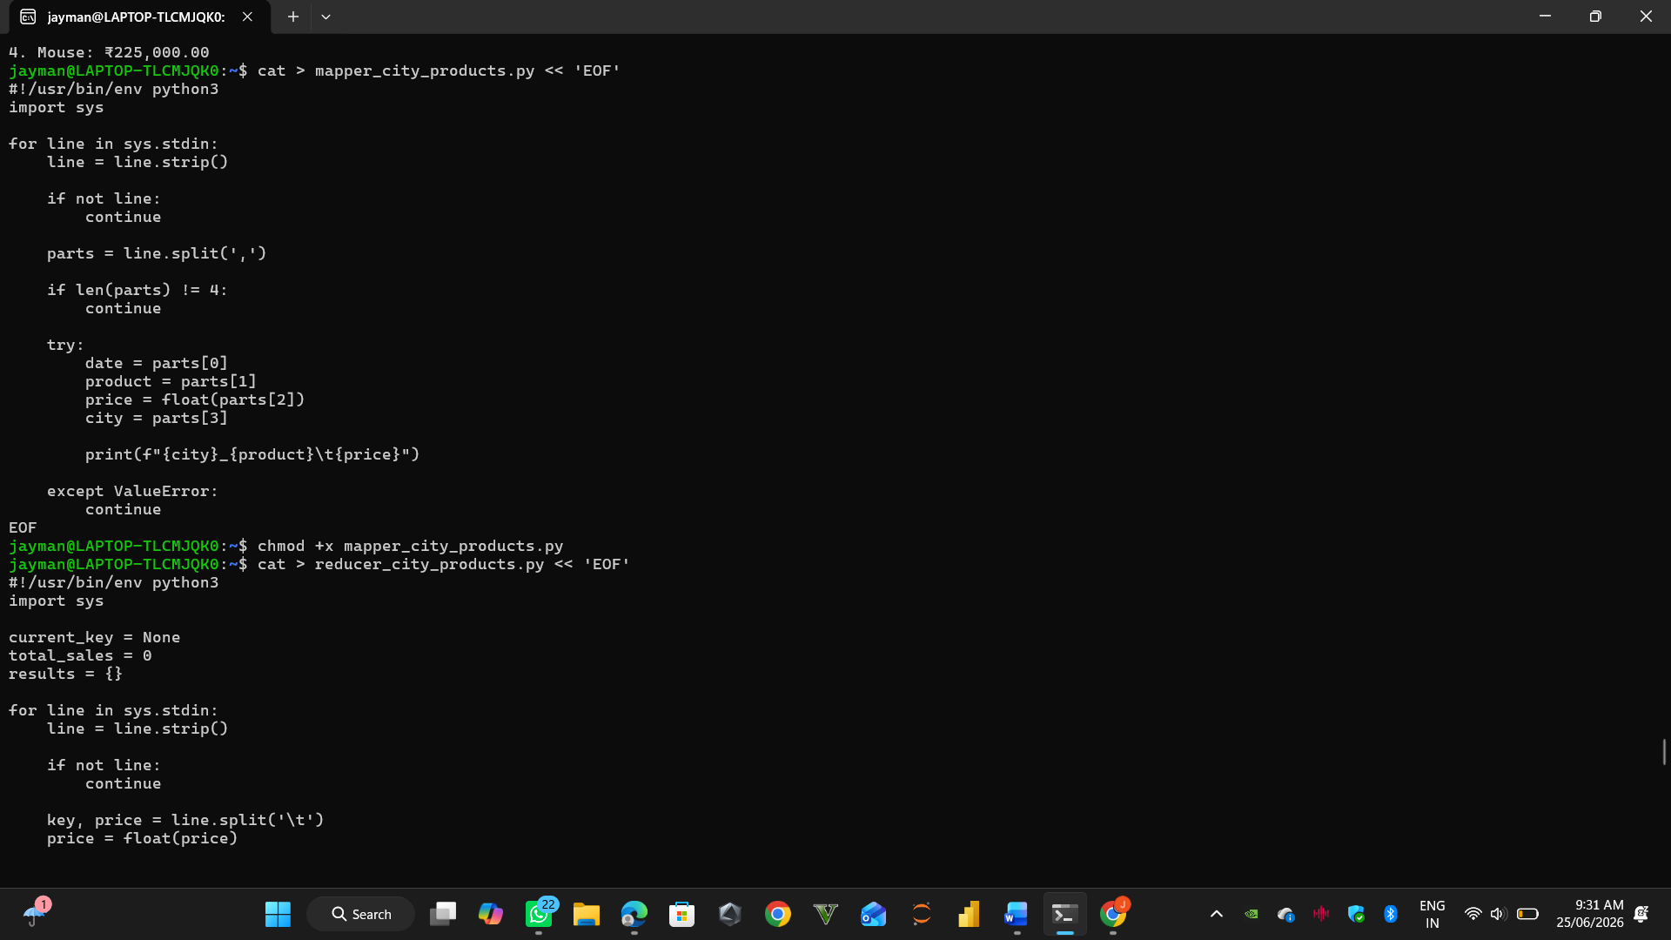
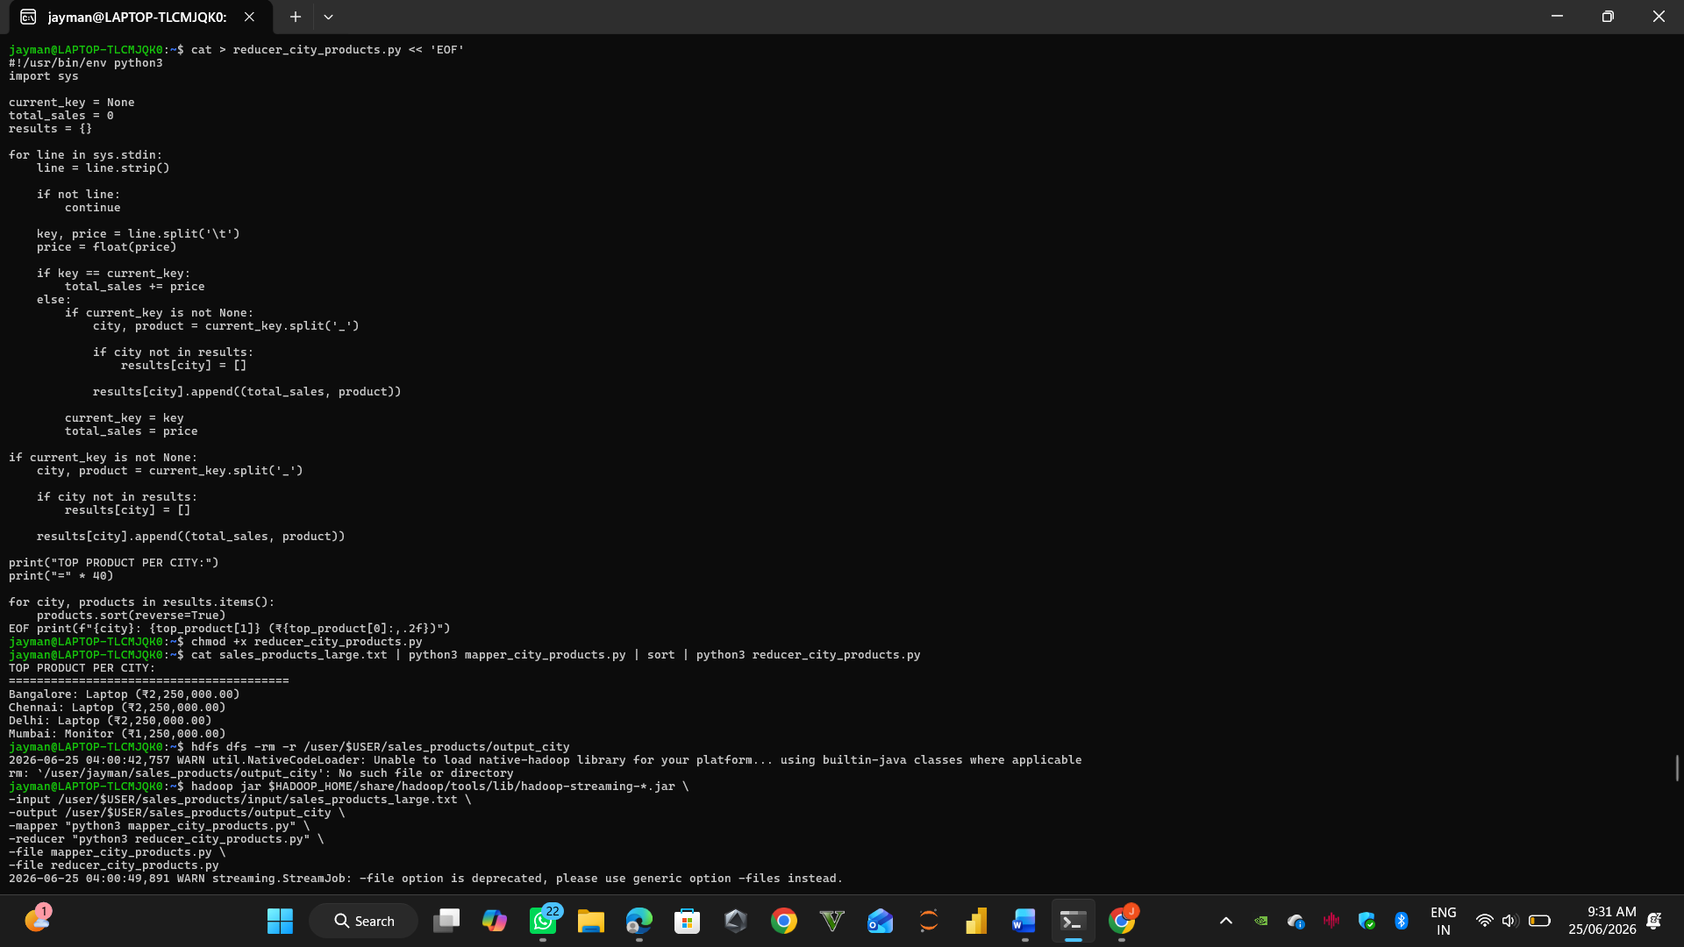
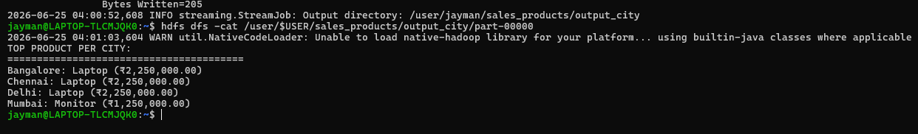
Conclusion
In this experiment, we successfully implemented a City-wise Product Sales Analysis using Hadoop MapReduce.
Key Outcomes:
- Mapper extracted city, product, and price information.
- Reducer aggregated sales per city-product pair.
- Final output identified the top-selling product in each city.
Learning:
- Learned how to use composite keys (city_product) in MapReduce.
- Understood grouping and aggregation in distributed systems.
- Implemented real-world e-commerce analytics use case using Hadoop.

